**Project Design Phase-I**

**Problem Solution Fit**

|  |  |
| --- | --- |
| **Date** | **28 October 2022** |
| **Team ID** | **PNT2022TMID42671** |
| **Project Name** | **IoT based smart crop protection system for agriculture** |

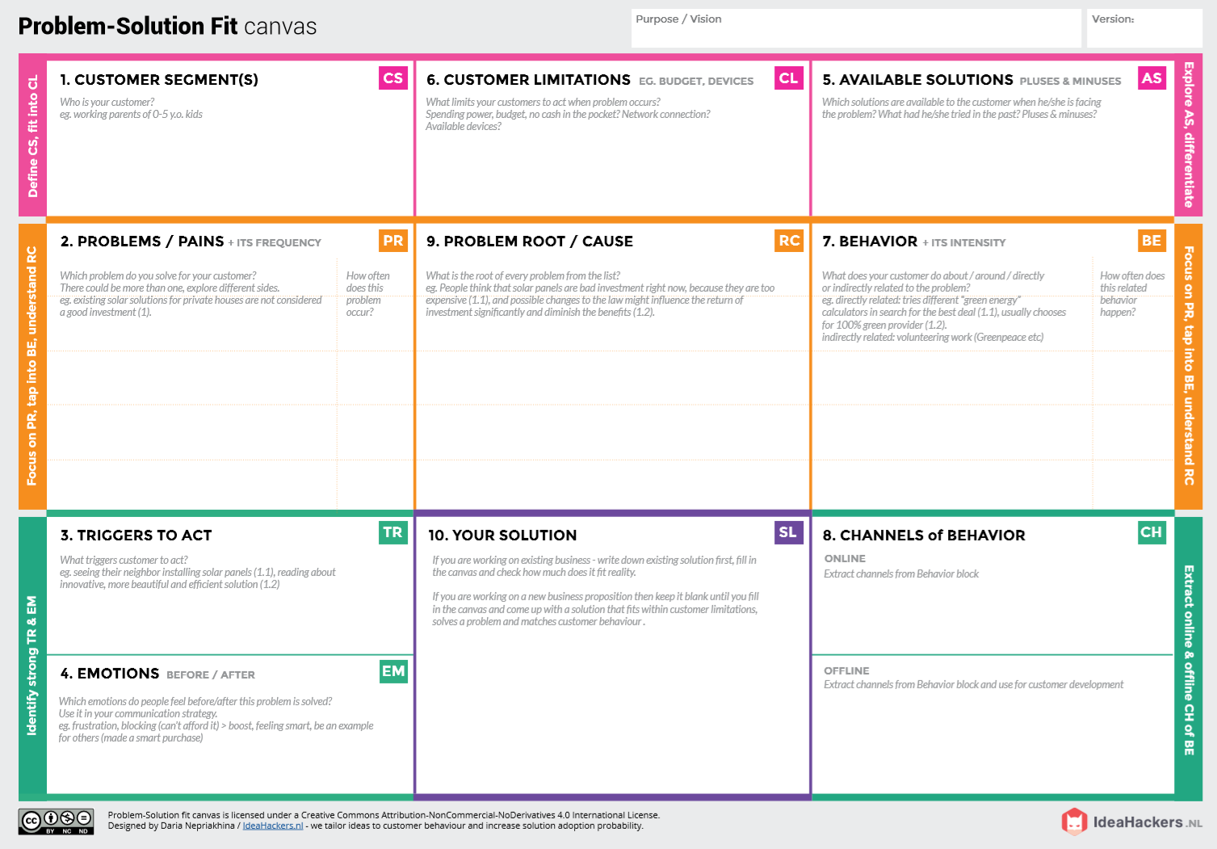

* Monitor different parameters and mobile or web application make easily to farm the crop field .

**BEFORE**: Financial issues, heavy workload, and marital discord.

**AFTER**: It will easier to make more yield in field

**Direct related**: Tries to find a solution to prevent this problem

**Indirect related**: Located in rural where internet connectivity might not be strong enough to facilitate fast transmission speeds.

* It’s difficult to monitor and control
* Requires protecting crops from Wild animals attacks, birds and pests.
* Ain’t known if the application doesn’t work properly.
* Farmers who trying to protect crops from various problems.

**OFFLINE**: Farmers use control measures to keep an eye on their fields.

**ONLINE:** The Data send through application for the farmers to know about the farms.

***“IoT based Smart crop protection system for agriculture” !!***

It help farmers grow more food on less land by protection crops from pests, diseases and weeds as well as raising productivity per hectare.

1)If the environment is seriously harmed by factors such as temperature,PH level,humidity and light intensity.

2)Farmer affected by less productivity which will affect in their profit.

1) Exorbitant adoption fees and security issues.

2)Not aware of the implementation of IoT in agriculture.

Create opportunities to lift people out of poverty in developing nations. (Over 60% )